ROLES AND USERS
Assignment 1: Snowflake Environment Setup (Beginner)
Objective: Understand Snowflake UI and basic objects.
Tasks
- Log in to Snowflake (trial account).
- Create:
  - A Database
create or replace database Rolesandusers;
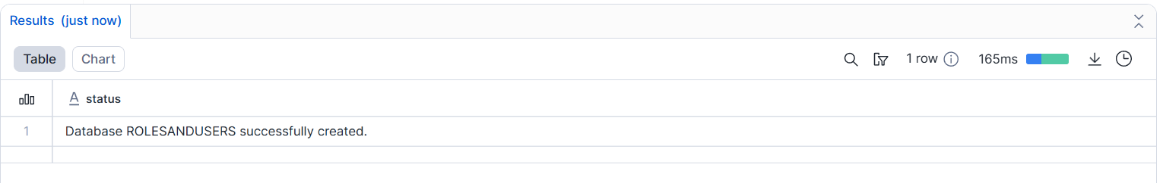
  - A Schema
create or replace schema roleuser;
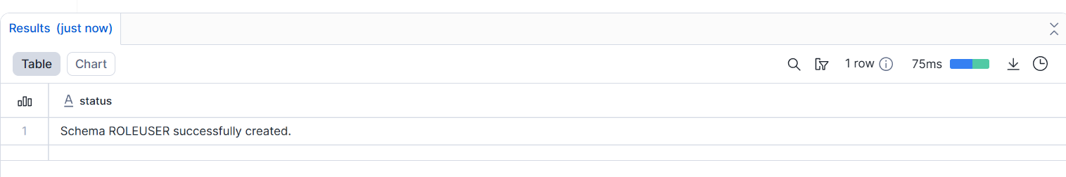
  - A Virtual Warehouse
create or replace warehouse role_wh;
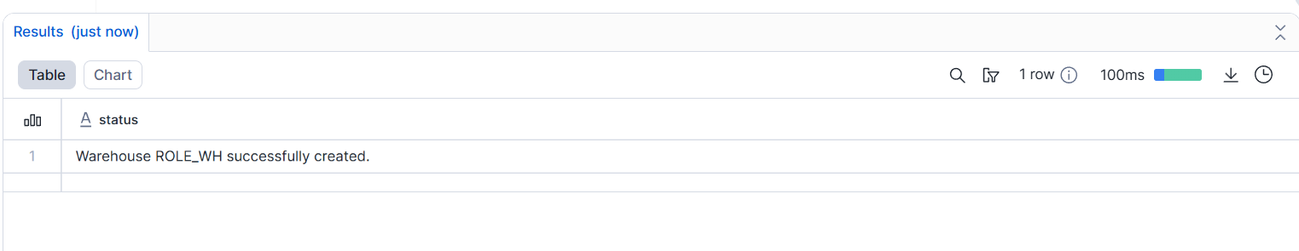
- Show all databases and schemas.
show databases;
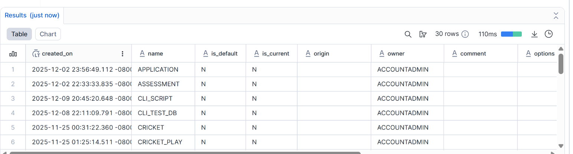
show schemas;
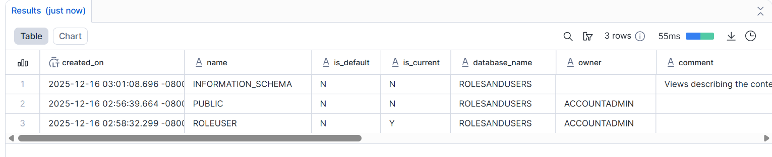
- Suspend and resume the warehouse.
alter warehouse role_wh suspend;
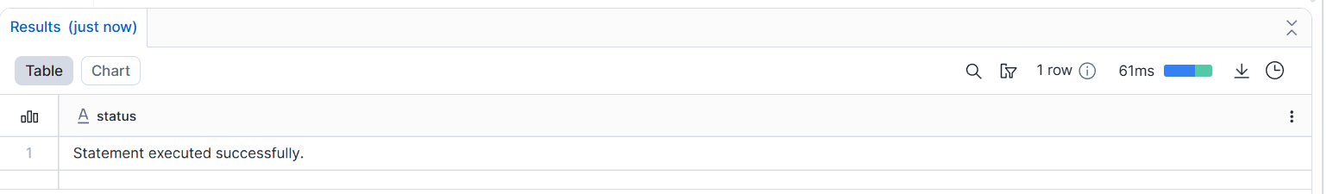
Deliverable:
- SQL script
- Screenshot of created objects

Assignment 2: User, Role & Access Control (RBAC)
Objective: Learn Snowflake security and role hierarchy.
Tasks
- Create roles:
  - STUDENT_ROLE
create role student_role;
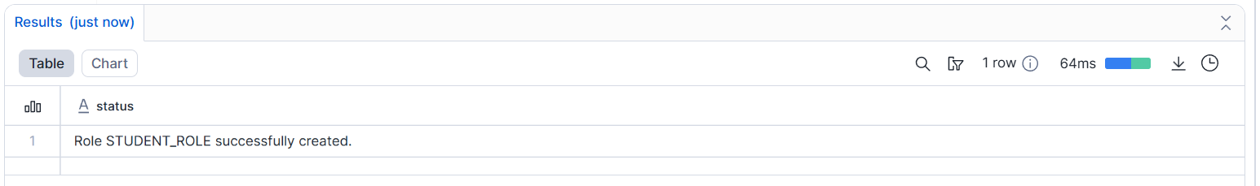
  - INSTRUCTOR_ROLE
create role instructor_role;
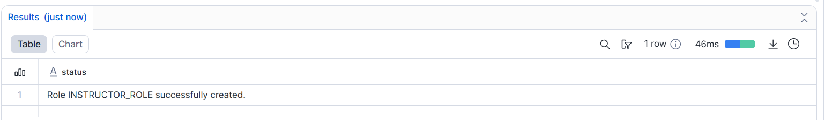
- Create users:
  - student1
create or replace user student1
password = "Student@123"
must_change_password = True
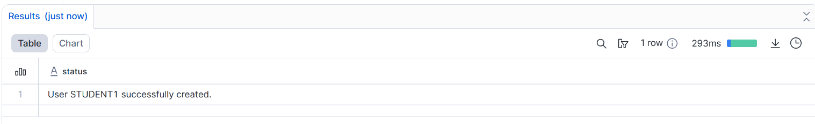
  - instructor1
create or replace user instructor1
password = "Instructor@123"
must_change_password = True
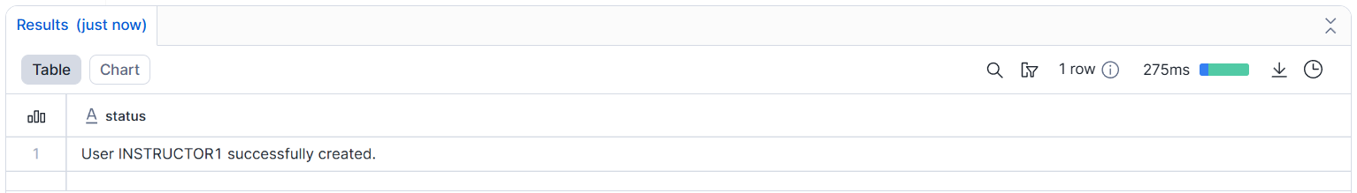
- Assign:
  - STUDENT_ROLE → student1
GRANT ROLE STUDENT_ROLE TO USER student1;
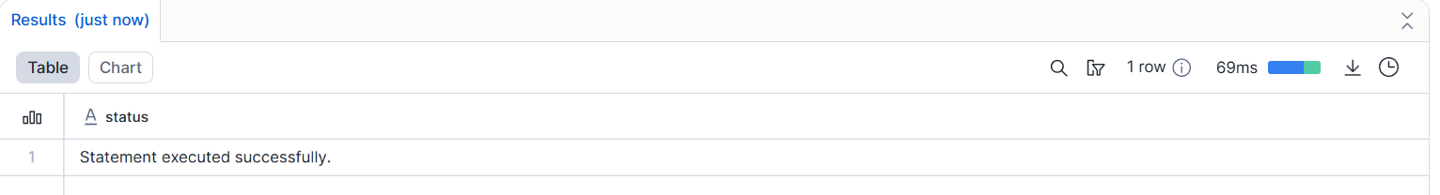
  - INSTRUCTOR_ROLE → instructor1
GRANT ROLE INSTRUCTOR_ROLE TO USER instructor1;
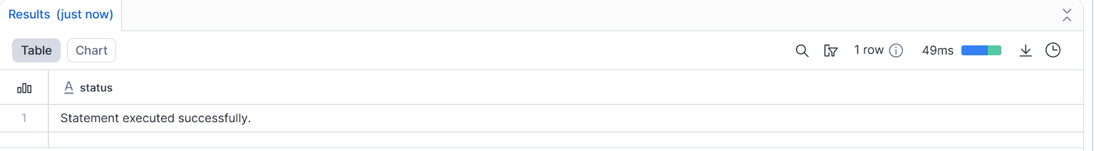
- Grant permissions:
  - Student → SELECT on tables
GRANT SELECT
ON TABLE students
TO ROLE STUDENT_ROLE;
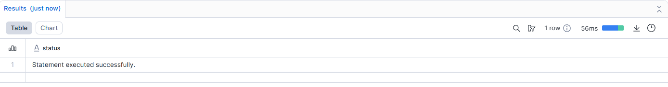
  - Instructor → SELECT, INSERT
GRANT SELECT, INSERT
ON TABLE students
TO ROLE INSTRUCTOR_ROLE;
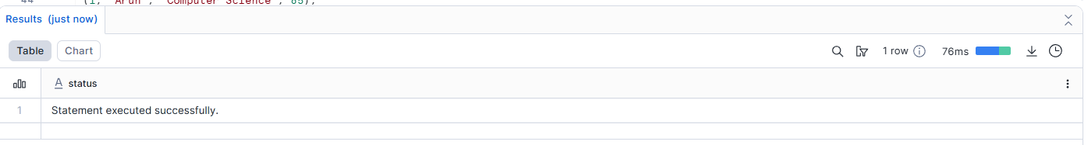
- Verify access using SHOW GRANTS.
SHOW GRANTS TO USER student1;
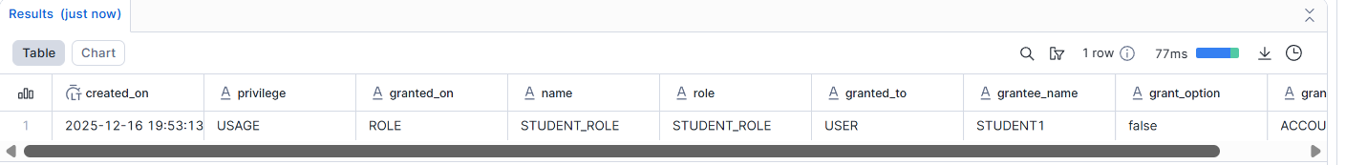
SHOW GRANTS TO USER instructor1;
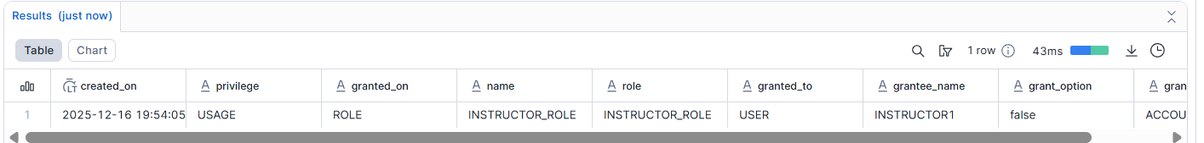
Deliverable:
- SQL commands
- Short explanation of RBAC

Assignment 3: Table Creation & Data Loading
Objective: Work with structured data.
Tasks
- Create a table:
CREATE TABLE students (
id INT,
name STRING,
course STRING,
score INT
);
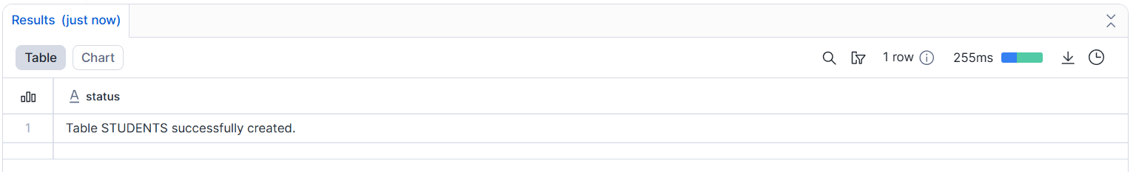
- Insert at least 10 records.
id,name,course,score
1,Arun,Computer Science,85
2,Priya,Information Technology,78
3,Karthik,Computer Science,92
4,Divya,Electronics,74
5,Suresh,Mechanical,68
6,Ananya,Computer Science,88
7,Vikram,Civil,71
8,Meena,Information Technology,90
9,Ravi,Electronics,66
10,Pooja,Mechanical,82
11,Naveen,Computer Science,95
12,Keerthi,Civil,73
13,Ajay,Information Technology,80
14,Lakshmi,Electronics,87
15,Manoj,Mechanical,69
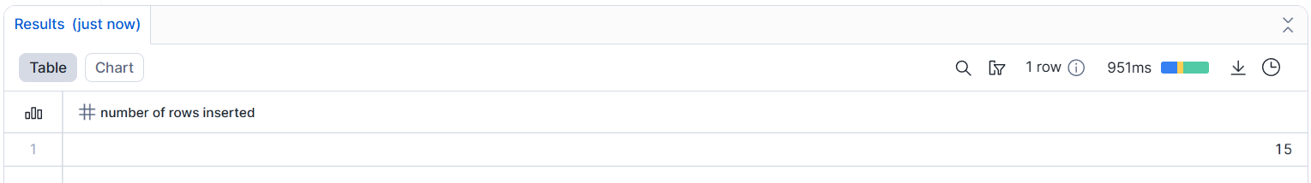
- Query:
  - All students
select * from students;
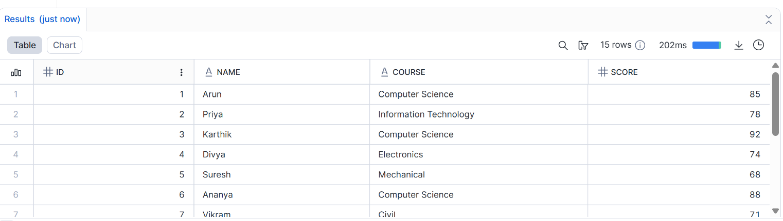
  - Students with score > 80
select * from students where score > 80;
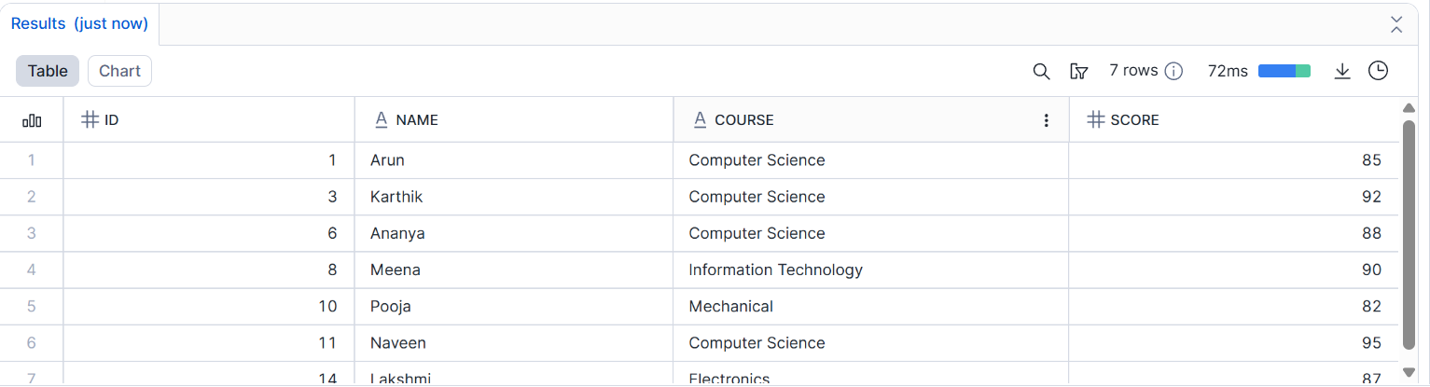
- Update one record.
Update students SET course = 'Viscom' where Name = 'Pooja';
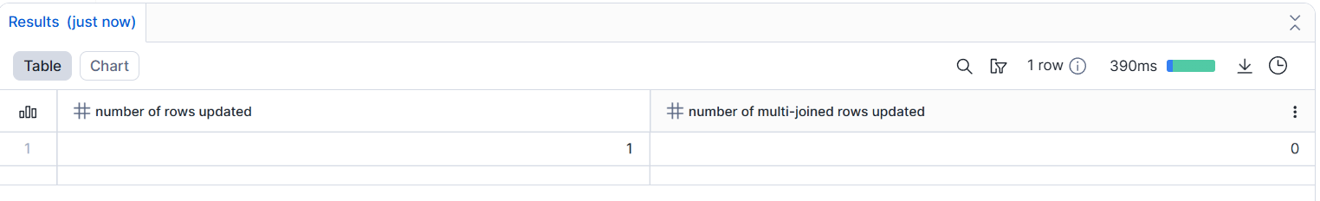
- Delete one record.
delete from students where id = 5;
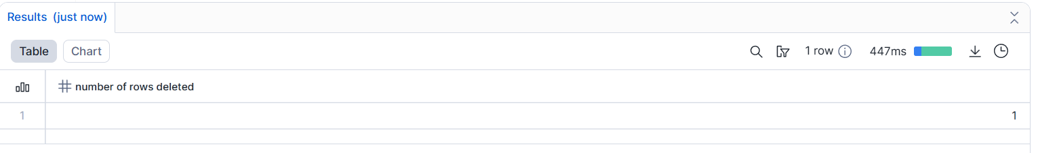
Deliverable:
- SQL file with queries
- Output screenshots

Assignment 4: File Loading using Stage & COPY (Intermediate)
Objective: Learn Snowflake data ingestion.
Tasks
- Create an internal stage.
create or replace stage ingestion;
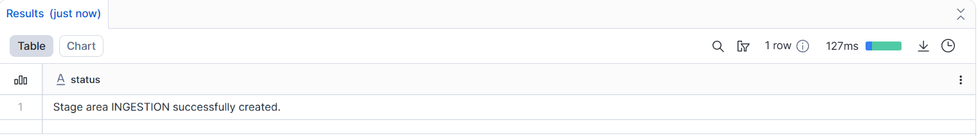
- Upload a CSV file.
- Use COPY INTO to load data.
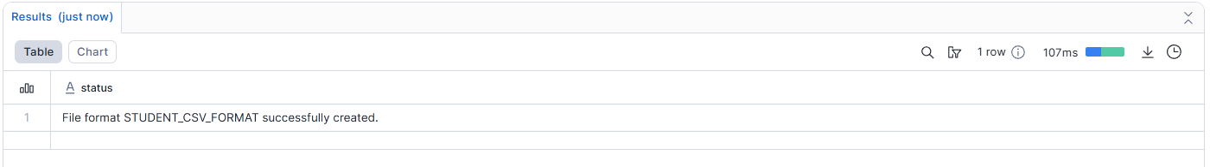
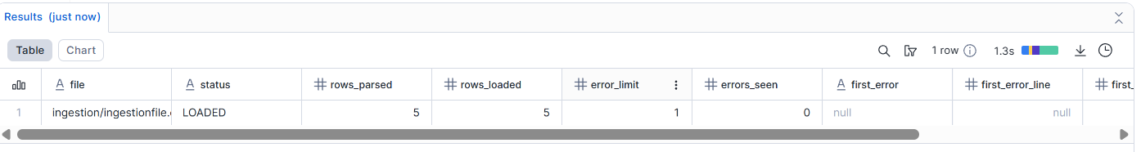
- Validate loaded records.
select * from students;
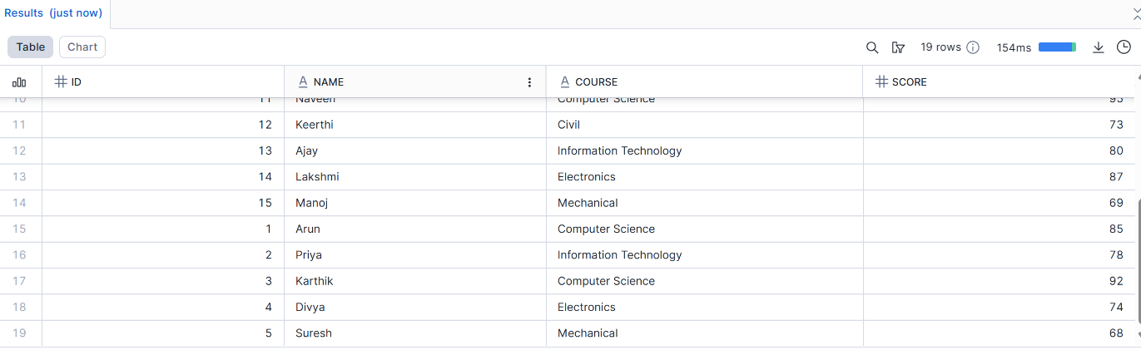
- Handle one data error using VALIDATION_MODE
COPY INTO students
FROM @ingestion
FILE_FORMAT = student_csv_format
VALIDATION_MODE = 'RETURN_ERRORS';
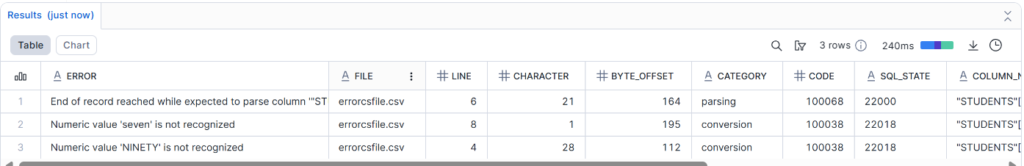
Deliverable:
- SQL script
- CSV file
- Query output

Assignment 5: Time Travel & Data Recovery
Objective: Understand Snowflake Time Travel.
Tasks
- Delete records from a table.
- Query data using Time Travel.
- Restore deleted data.
- Explain how Time Travel helps in recovery.
Deliverable:
- SQL queries
- Short explanation

Assignment 6: Warehouses & Performance
Objective: Learn compute management.
Tasks
- Create:
  - SMALL_WH
CREATE OR REPLACE WAREHOUSE SMALL_WH
WAREHOUSE_SIZE = 'SMALL'
AUTO_SUSPEND = 60
AUTO_RESUME = TRUE
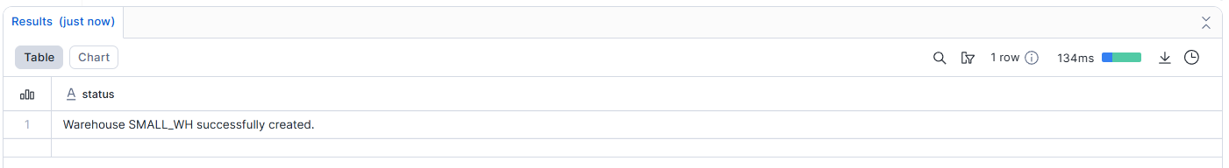
  - MEDIUM_WH
CREATE OR REPLACE WAREHOUSE MEDIUM_WH
WAREHOUSE_SIZE = 'MEDIUM'
AUTO_SUSPEND = 60
AUTO_RESUME = TRUE
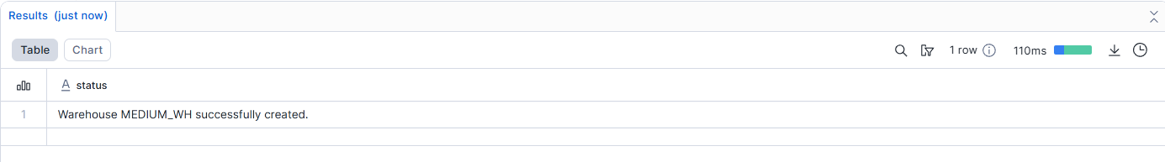
- Run same query on both warehouses.
USE WAREHOUSE SMALL_WH;
SELECT course, AVG(score) AS avg_score
FROM students
GROUP BY course; 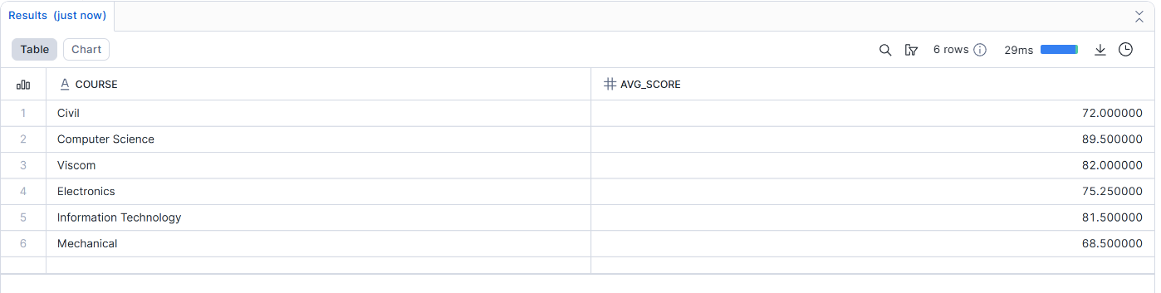
USE WAREHOUSE MEDIUM_WH;
SELECT course, AVG(score) AS avg_score
FROM students
GROUP BY course;
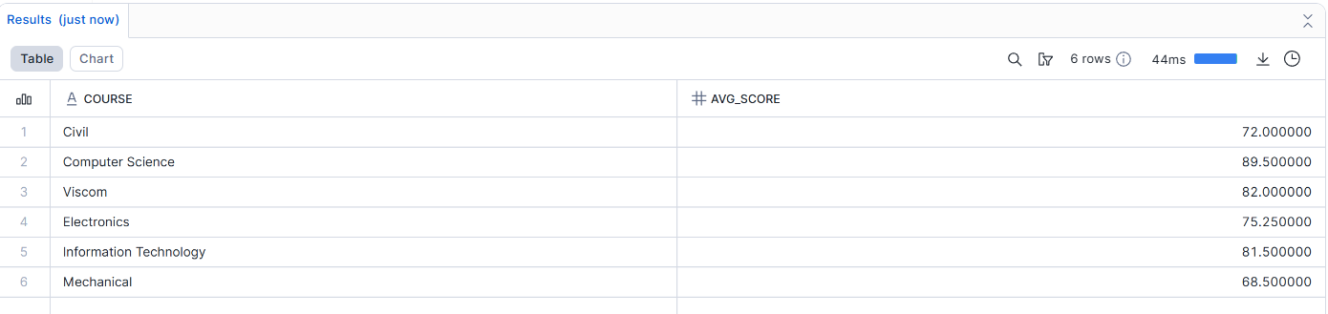
- Compare execution time.
- Suspend unused warehouse.
ALTER WAREHOUSE MEDIUM_WH SUSPEND;
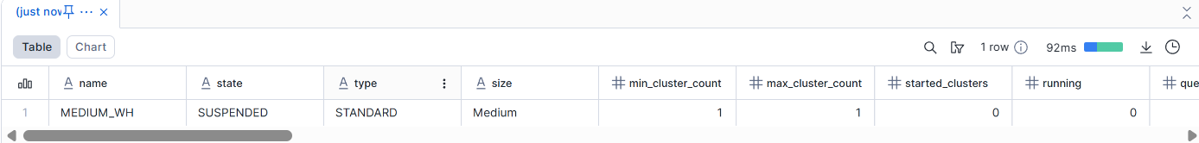
Deliverable:
- Query history screenshot
- Performance comparison notes

Assignment 7: Views & Secure Views
Objective: Control data visibility.
Tasks
- Create a View hiding sensitive columns.
CREATE OR REPLACE VIEW students_view AS
- SELECT
id,
name,
Course
FROM students;
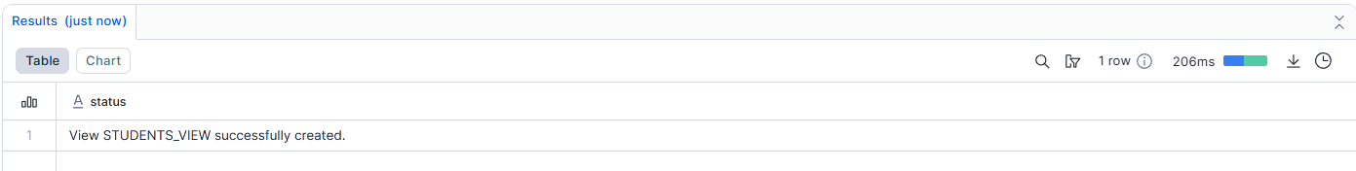
select * from students_view
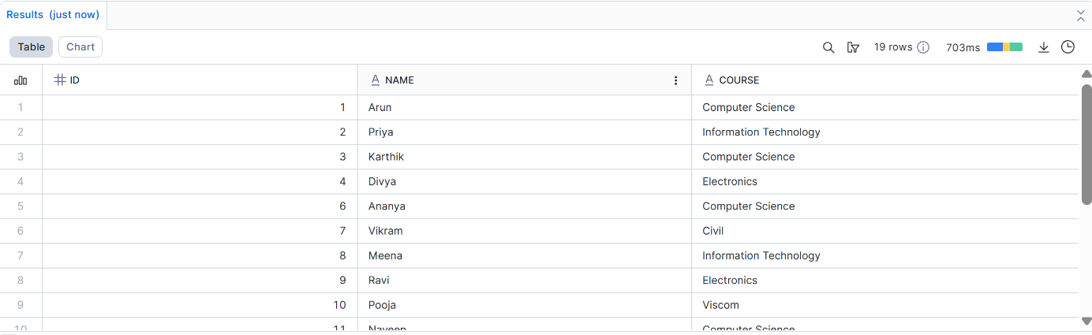
- Create a Secure View.
CREATE OR REPLACE SECURE VIEW secure_view AS
SELECT
id,
name,
Course
FROM students;
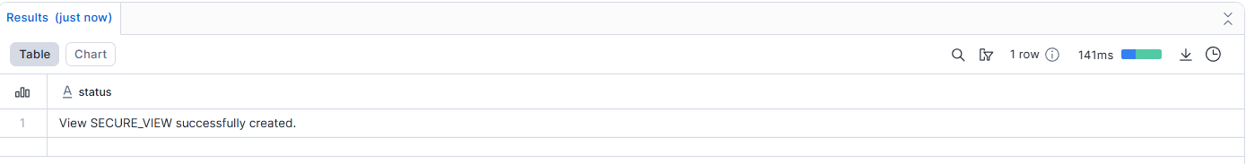
select * from secure_view
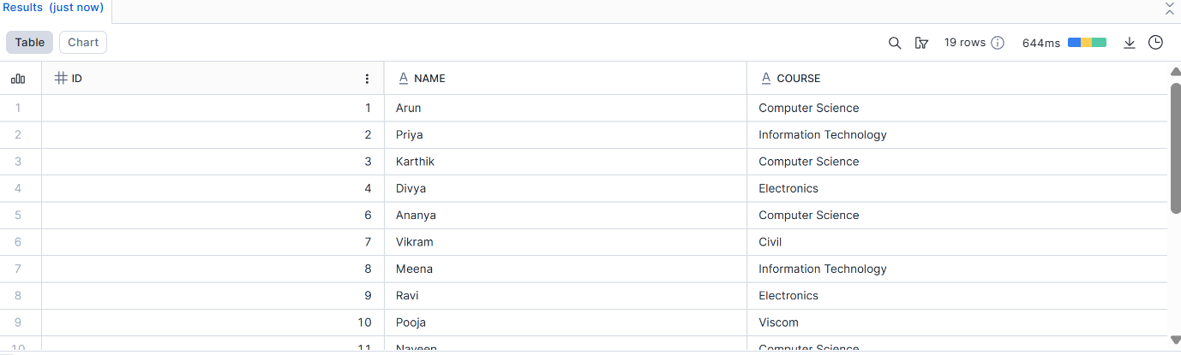
- Grant view access to Student role.
GRANT SELECT ON VIEW secure_view TO ROLE STUDENT_ROLE;
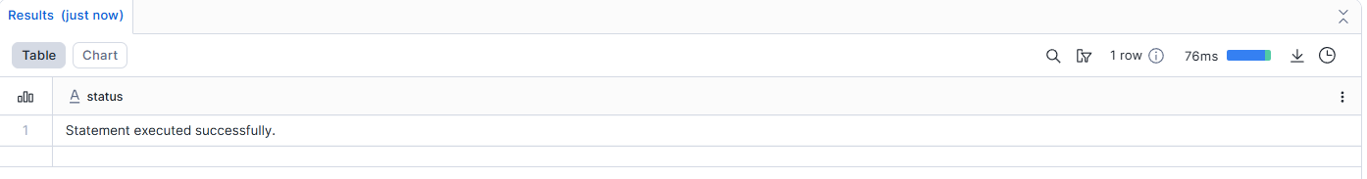
- Test access using Student role.
SELECT * FROM secure_view;
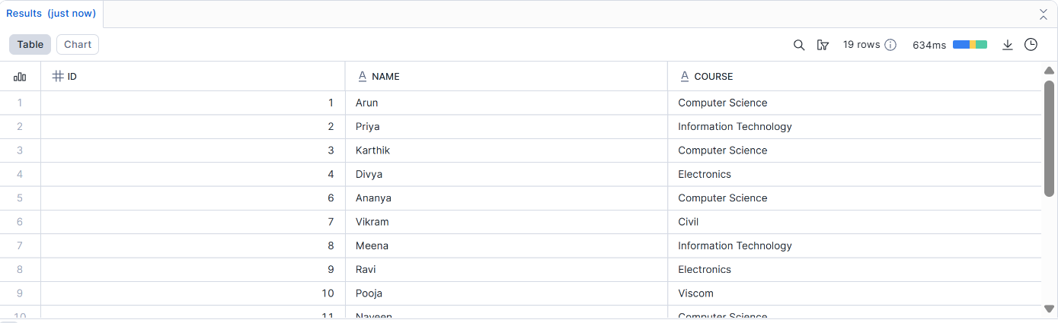
Deliverable:
- SQL queries
- Explanation of Secure View

Assignment 8: Scaling & Auto Suspend (Advanced)
Objective: Understand Snowflake scaling behavior.
Tasks
- Enable auto-suspend and auto-resume.
- Configure multi-cluster warehouse.
- Simulate concurrent queries.
- Observe scaling behavior.
Deliverable:
- Warehouse configuration
- Query history evidence

